Roberts Moore, Regional Sales Representative
CC: Dave Manchester, Vice-President of Sales
Jeff Dalik, Bike Doctor Linthicum
Dear Mr. Moore,
I wanted to inquire about a possible cyclocross and ultra-cross sponsorship for my team/charity's elite racers. Our team is Adventures For the Cure (AFC), we are a bunch of cyclists, triathletes, and duathletes from the Baltimore area who use our sport to help raise money for charity (in particular we focus on raising money for a diabetes camp for kids called Extreme Weekend and another organization that helps children with disabilities in Kenya called Kupenda for the Children). AFC has absolutely NO overhead costs, 100% of our the money we raise goes to our charities!! All of the money that our elite team wins at races goes directly as a donation to the charity.
Last year we create an AFC Cross Campaign to raise money for our charity during the cyclocross season. As usual all of our race winnings went to the charity, but we also had friends/family/local business donate based on our race results. We were able to raise over $3k. We will be doing a 2012 campaign and we hope to raise even more this year!
Our team has about 100 members total and our Elite Team is comprised of 3 racers:
1) Adam Driscoll - President of AFC, Cat 1 Cyclocross Racer, Ultra Cross Racer, has type 1 diabetes. Adam's Blog.
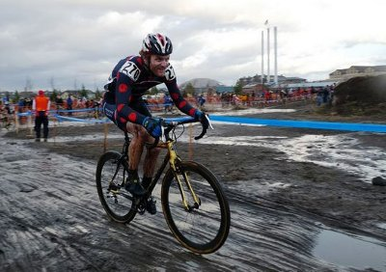
(Adam at Cyclocross Nationals)

2) Patrick Blair - Vice President of AFC, Cat 1 Cyclocross Racer, Ultra Cross Racer, NUE Racer. Patrick's Blog.
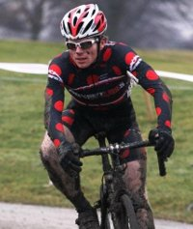
(Patrick at Chicago New Year's Cross)
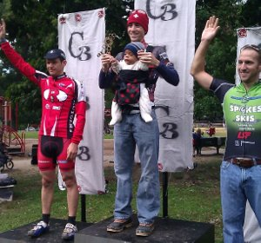
3) Lance Byrd - Financial supporter of AFC's charities, Cat 3 Cyclocross Racer, Ultra Cross Racer. Lance's Blog.
(Lance on the top step of the podium at Charm City Cross)
Adam, Lance and I all competed in the Hilly Billy Ultra Cross Race and were interviewed by CyclingDirt.org. CyclingDirt.org has done numerous videos of us, not because we are fast or have good results, but because they love our charity work and enthusiasm.
Last year Adam and I finished 8th and 3rd respectively in the MABRA Super 8 Elite Series and Lance won the Sportif Cross Cup Elite.
We are planning on racing at the Elite Level in the local MABRA series and Iron Cross this season coming up.
Our team is in desperate need of new cross frames. We were hoping that you might be interested in partnering with us. We could really use the help so that we can be riding the best stuff, to beat the best guys, and to raise a lot of $$ and awareness for our charity!!
Thanks for your consideration!!!!
Patrick Blair

